**Experiment 6:** To Study Agile Methodology and Test Case Management using JIRA Tool.

**Theory:**

# Introduction to Agile Methodology

Agile methodology is a flexible, iterative, and collaborative approach to software development and project management. It focuses on continuous improvement, rapid delivery, and adaptability to changing requirements. Agile follows an incremental approach, where projects are divided into smaller iterations (sprints), allowing teams to deliver working software quickly and efficiently.

# Key Principles of Agile (According to the Agile Manifesto)

1. Individuals and interactions over processes and tools.
2. Working software over comprehensive documentation.
3. Customer collaboration over contract negotiation.
4. Responding to change over following a plan.

These principles emphasize flexibility, customer involvement, and iterative development to improve efficiency and adaptability.

# Agile Frameworks and Approaches

Agile is an umbrella term that includes various frameworks, such as:

1. Scrum – A structured framework with defined roles (Scrum Master, Product Owner, Development Team) and time-boxed iterations called sprints.
2. Kanban – A visual workflow management system that helps teams track work progress using a Kanban board.
3. Extreme Programming (XP) – Focuses on engineering practices such as test-driven development (TDD) and pair programming.
4. Lean – Aims to eliminate waste and improve efficiency.
5. SAFe (Scaled Agile Framework) – A framework for applying Agile at the enterprise level.

Among these, Scrum and Kanban are widely used in software development projects.

# Test Case Management in Agile Development

Test case management is a crucial aspect of software testing in Agile. Since Agile follows shorter development cycles, testing is done continuously to ensure that software is stable and defect-free.

# Key Aspects of Test Case Management in Agile

* Continuous Testing – Testing occurs throughout the sprint, ensuring early bug detection.
* Automated Testing – Automation is widely used to speed up testing and reduce manual effort.
* User Story-Based Testing – Test cases are aligned with user stories rather than traditional detailed test plans.
* Exploratory Testing – Testers actively explore the application instead of following strict test scripts.
* Collaboration with Developers – Testers, developers, and business analysts work together to validate requirements and test cases.

Since Agile follows rapid iterations, test case management tools like JIRA are widely used for test planning, execution, and reporting.

**JIRA as a Test Case Management Tool**

# Introduction to JIRA

JIRA is a popular project management and issue-tracking tool developed by Atlassian. It is widely used in Agile development for bug tracking, task management, and test case management. JIRA supports Agile methodologies like Scrum and Kanban, making it an ideal tool for software teams.

# Features of JIRA for Test Case Management

1. Test Case Creation – JIRA allows teams to create, organize, and manage test cases as part of their development workflow.
2. Test Execution – Test cases can be executed manually or integrated with automation tools.
3. Bug Tracking – Defects found during testing can be logged and assigned to developers for resolution.
4. Integration with CI/CD Tools – JIRA integrates with tools like Jenkins, Selenium, and TestRail for automated testing.
5. Custom Dashboards and Reports – JIRA provides real-time tracking of test progress, defect status, and test coverage.
6. Sprint Management – Teams can track test cases and bugs across different sprints.

# How JIRA is Used in Agile Testing

1. Creating User Stories and Test Cases

* 1. In Agile, test cases are linked to user stories to ensure that every feature is tested.

○ Testers write test cases in JIRA tickets and track their execution during sprints.

1. Logging and Tracking Bugs

* 1. If a bug is found, it is logged in JIRA as an issue with details like severity, priority, and steps to reproduce.

○ The bug is assigned to a developer for fixing.

1. Executing Test Cases

* 1. Testers execute test cases and update their status as Passed, Failed, or Blocked in JIRA.

○ Automation tools can be integrated with JIRA to run tests and update results automatically.

1. Reporting and Analytics

* 1. JIRA provides dashboards with insights into test execution progress, defect trends, and sprint performance.

○ Teams use these reports for decision-making and sprint retrospectives.

# Advantages of Using JIRA for Test Case Management

* Seamless Integration with Agile Workflows – JIRA fits perfectly into Agile methodologies like Scrum and Kanban.
* Collaboration Between Teams – Developers, testers, and product owners can track project progress in one place.
* Automation and CI/CD Integration – Reduces manual effort by integrating with automated testing tools.
* Custom Workflows – JIRA allows teams to define their own workflows for test execution, defect tracking, and reporting.
* Improved Visibility – Dashboards and reports provide real-time insights into test progress and defect status.

**Output:**

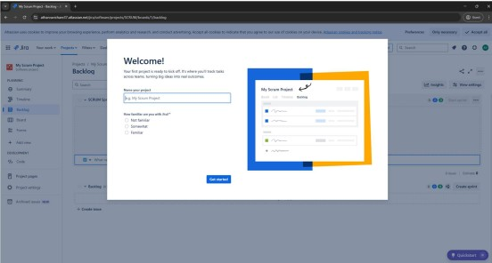

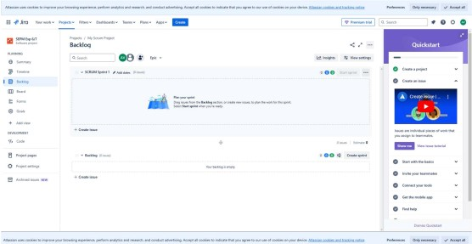

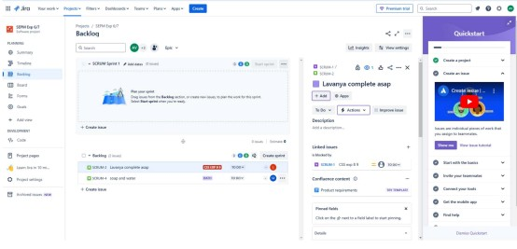

**Conclusion:**

Successfully implemented Agile Methodology and Test Case Management using JIRA Tool.